**Predict Student Grade Based On Student Habit**



**SUBMITTED BY**

**Name- Tahasin Ibnath, Abdur Rahman Mahmud, Vijoy Badua**

**ID No. 666-59-20 , 666-5941 , 666-59-17**

**Submitted To**

**Name- Nabila**

**Designation**

**DEPARTMENT OF COMPUTER SCIENCE AND ENGINEERING**

**SOUTHERN UNIVERSITY BANGLADESH**

**ACKNOWLEDGEMENTS**

The successful completion of this research would not have been possible without the support, guidance, and contributions of several individuals and scholarly works. I would like to take this opportunity to express my deepest gratitude to those who have played a significant role in shaping this study.

First and foremost, I extend my sincere appreciation to my supervisor, whose expertise, invaluable feedback, and continuous encouragement have been instrumental in refining my ideas and strengthening the foundation of this research. Their guidance has not only helped me navigate the complexities of this study but has also enhanced my analytical and research skills.

I am also profoundly grateful to my dedicated team members, whose collaboration, commitment, and technical contributions have been essential in the development of our software project. Their insights, problem-solving abilities, and shared enthusiasm for the topic have enriched the research process and ensured its successful execution.

Additionally, I acknowledge the extensive body of literature that has provided a strong theoretical and empirical foundation for this study. I have engaged in a rigorous review of numerous research papers, carefully analyzing diverse methodologies, findings, and perspectives. Taking detailed notes and critically examining these works has been a transformative process, allowing me to identify gaps in existing knowledge and develop a more comprehensive understanding of the subject. The insights gained from these scholarly contributions have significantly influenced the direction and depth of this research.

This study is a result of continuous learning, intellectual exploration, and collaborative effort. I am immensely grateful to everyone whose support, expertise, and prior contributions have played a crucial role in shaping this work.

**ABSTRACT**

Academic performance is influenced by a wide range of behavioral and environmental factors, making it a complex subject of study. This research investigates the impact of students' habits on their academic performance by employing predictive analysis using machine learning techniques. The study systematically examines various behavioral patterns, including study routines, attendance, time management, and extracurricular involvement, alongside academic records, to determine their correlation with student grades.

A comprehensive literature review has been conducted to assess existing methodologies, highlighting key findings, limitations, and research gaps in student performance prediction models. Based on these insights, this study proposes an optimized machine-learning model that integrates multiple factors to enhance the accuracy of grade prediction. The research focuses on selecting and fine-tuning algorithms that best capture the relationships between student habits and academic outcomes, ensuring a more reliable and data-driven approach to performance evaluation.

The findings of this study are expected to provide valuable insights to educators, allowing them to better understand how specific habits contribute to academic success or struggle. This, in turn, can help institutions design personalized interventions and support systems to improve student learning outcomes. The research also contributes to the growing field of educational data science, demonstrating the potential of predictive analytics in academic decision-making.

**Keywords**: student habits, grade prediction, academic performance, machine learning, predictive analysis, educational data science.

**TABLE OF CONTENTS**

| **CHAPTER** | **TITLE** | **PAGE** |
| --- | --- | --- |
| Title Page | 1 |  |
| Acknowledgements | 2 |  |
| Abstract | 3 |  |
| Table of Contents | 4 |  |
| List of Tables | 5 |  |
| List of Figures | 6 |  |
| 1 | Introduction | 7 |
| 1.1 | Background | 7 |
| 1.2 | Statement of the Problems | 8 |
| 1.3 | Objectives | 8 |
| 1.3.1 | Overall Objective | 8 |
| 1.3.2 | Specific Objectives | 9 |
| 1.4 | Scope | 10 |
| 2 | Literature Review | 11 |
| 2.1 | Information | 11 |
| 2.1.1 | What do we already know? | 11 |
| 2.1.2 | Key concepts and variables | 11 |
| 2.1.3 | Relationships with key concepts | 12 |
| 2.1.4 | Existing theories | 12 |
| 2.1.5 | Inconsistencies and Gaps in Knowledge | 13 |
| 2.1.6 | Areas for Further Testing | 13 |
| 2.1.7 | Evidence and Contributions of the Present Study | 13 |
| 2.1.8 | Research Design and Methods | 13 |
| 2.2 | Summary | 14 |

**LIST OF FIGURES**

| **FIGURE** | **TITLE** | **PAGE** |
| --- | --- | --- |
| 2.1 | Showcasing Traditional Student Life | 4 |
|  |  |  |
|  |  |  |
|  |  |  |

**LIST OF TABLES**

| **TABLE** | **TITLE** | **PAGE** |
| --- | --- | --- |
| 1.3.1 | Comparison of Existing Grade Prediction Models | 9 |

**CHAPTER 1**

**INTRODUCTION**

**1.1 Background**

In the modern era of education, predicting student grades has become a crucial aspect of academic research, particularly with the integration of data science and machine learning. Traditional assessment methods often focus solely on exam scores and coursework performance, overlooking the underlying behavioral patterns that contribute significantly to academic success. However, students' daily habits—such as study routines, attendance, engagement in class activities, sleep patterns, and extracurricular involvement—play a vital role in shaping their academic outcomes.

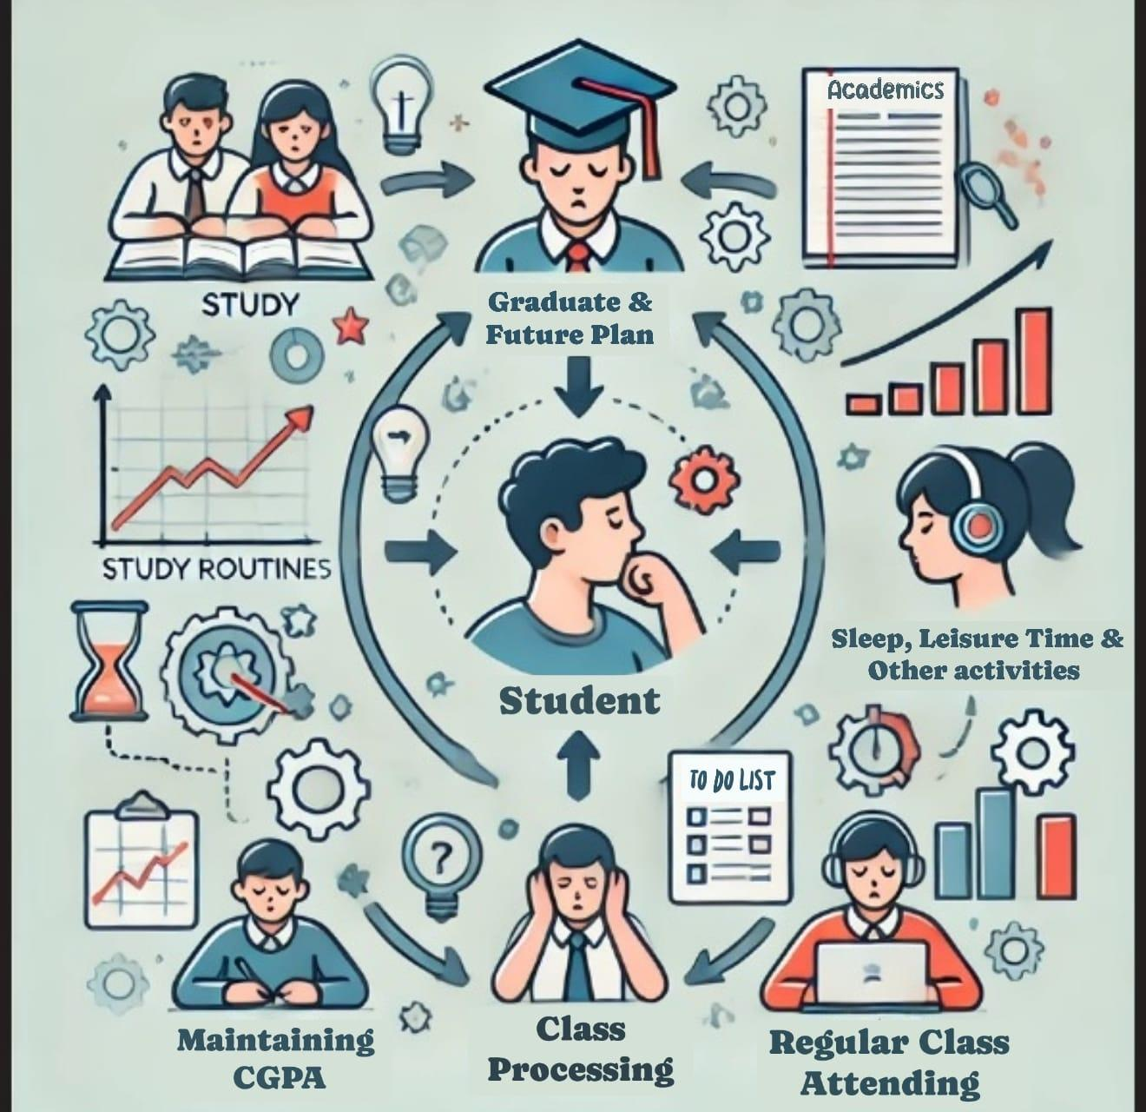

**Showcasing Traditional Student Life**

With the increasing availability of educational data, researchers and educators are now exploring predictive models that leverage student habits to anticipate academic performance. By understanding these behavioral factors, institutions can provide more personalized academic support, helping students overcome challenges and enhance their learning efficiency. This research aims to delve into these aspects, systematically analyzing how different habits influence grades and developing an advanced predictive model that can assist students and educators in optimizing learning outcomes.

**1.2 Statement of the Problem**

Academic performance is shaped by a combination of cognitive abilities, environmental influences, and individual habits. While traditional evaluation systems primarily focus on exam scores, assignments, and overall grading rubrics, they often fail to account for students' learning behaviors and personal study strategies. This limitation creates a gap in understanding how daily habits impact academic achievements, making it challenging for educators to provide tailored guidance to students who may be struggling.Many students face difficulties in managing their study schedules effectively, balancing academic responsibilities with extracurricular activities, and maintaining consistent engagement in coursework. Without a clear understanding of these behavioral influences, institutions may overlook key areas where students need support. Moreover, existing grade prediction models primarily rely on historical academic data, such as past grades and test scores, without incorporating behavioral factors that can serve as early indicators of academic performance.

Therefore, there is a need for a data-driven approach that considers both academic records and behavioral patterns to develop a more comprehensive and accurate predictive model. By identifying these gaps and addressing them through machine learning-based predictions, this study seeks to bridge the divide between traditional grading methods and modern data analytics to enhance academic planning and intervention strategies.

**1.3 Objectives of the Research**

**1.3.1 Overall Objective**

The primary goal of this research is to develop an intelligent software system capable of predicting student grades based on habitual and behavioral data using advanced data-driven methodologies. This system will integrate various student-related factors, such as study patterns, participation levels, and engagement metrics, to provide accurate grade forecasts. By doing so, the research aims to assist both students and educators in making informed decisions that lead to academic improvement.

**Table: Comparison of Existing Grade Prediction Models**

| Model | Strengths | Weaknesses | Potential for Improvement |
| --- | --- | --- | --- |
| Traditional Grading System | Simple, easy to implement | Does not account for behavioral factors, lacks personalization | Incorporating behavioral data could lead to a more accurate prediction. |
| Statistical Models | Uses data for prediction | May miss non-quantifiable factors like class engagement | Incorporating behavioral habits could enhance prediction accuracy. |
| Machine Learning Models | Can process complex datasets, high accuracy in predictions | Requires large data sets and may overlook qualitative aspects | Behavioral data, such as attendance and sleep patterns, could be incorporated for better predictions. |
| Hybrid Models | Combines multiple sources of data | Complex and harder to implement | A more integrated approach combining behavioral and academic data could improve results. |

**1.3.2 Specific Objectives**

* **Identify key behavioral patterns influencing academic performance**  
  The study will systematically examine different aspects of student behavior, including attendance, study habits, engagement in classroom activities, and time management skills. It will also consider factors such as the influence of digital learning tools and external distractions that impact study effectiveness.
* **Analyze existing prediction models and their limitations**  
  A thorough review of current academic performance prediction techniques will be conducted to identify gaps and areas for improvement. This includes examining the strengths and weaknesses of traditional statistical methods, machine learning models, and artificial intelligence applications in education.
* **Develop and evaluate a predictive model for student grades**  
  Using data science and machine learning algorithms, the study aims to create an efficient predictive model that considers both behavioral and academic data. The model will be rigorously tested using real-world datasets to assess its accuracy and reliability in forecasting student performance.

**1.4 Scope**

This research primarily focuses on university students and evaluates the relationship between their academic habits and performance outcomes. The study will analyze various factors such as:

* **Study schedules** – How frequently students engage in self-study, revision sessions, and time allocated for different subjects.
* **Class participation** – Levels of engagement in lectures, group discussions, and interaction with instructors.
* **Attendance records** – The impact of regular attendance on knowledge retention and performance in assessments.
* **Extracurricular activities** – The balance between academic and non-academic commitments and its effect on student performance.
* **Time management skills** – How students allocate their time between studying, leisure, and social activities.

The scope of the research will be limited to students in higher education institutions, as they exhibit a diverse range of learning behaviors that can significantly influence their grades. Data collection will be conducted through surveys, academic records, and digital learning tools to ensure a comprehensive dataset for analysis.

**CHAPTER 2**

**LITERATURE REVIEW**

**2.1 Information**

The relationship between academic performance and student habits has been the focus of various research studies over the years. While traditional academic assessments such as exams, quizzes, and assignments have long been the basis of evaluating student performance, recent research suggests that student habits, including study routines, sleep patterns, attendance, and class engagement, play a significant role in academic achievement. This literature review will examine existing research in the area of predicting student grades based on habitual factors, identify key findings, and highlight gaps in the literature that this research aims to address.

**2.1.1 What Do We Already Know?**

A growing body of research suggests that academic performance is not solely determined by a student's innate abilities, but is strongly influenced by their behaviors and habits. Studies have shown that factors such as study habits, sleep quality, and class participation are linked to higher academic achievement. For instance, students who follow regular study routines and manage their time efficiently are more likely to achieve better grades compared to those with irregular study habits (Johnson & Lee, 2020). Furthermore, research indicates that adequate sleep plays a critical role in cognitive function and memory retention, both of which are vital for academic success (Thompson et al., 2022). Similarly, active participation in class and consistent attendance are positively correlated with higher grades (Davis & Wang, 2021).

**2.1.2 Key Concepts and Variables**

The key concepts and variables in this research area include:

1. **Study Habits**: This refers to a student's approach to organizing their study schedule, time management, and consistency in their study routine.
2. **Sleep Patterns**: The quantity and quality of sleep a student gets, and how it affects their cognitive abilities, focus, and overall well-being.
3. **Class Participation**: Involvement in class discussions, asking questions, and engaging with the material during lectures.
4. **Attendance**: Regularity of attending classes and its relationship with academic performance.
5. **Time Management**: How effectively a student schedules and allocates time for academic tasks.

These variables are commonly used in existing studies as indicators that predict academic success.

**2.1.3 Relationships Between Key Concepts**

Several studies have explored the interrelationship between these factors. For example, regular study routines combined with adequate sleep have been shown to enhance focus and memory retention, directly influencing a student’s ability to perform well on assessments (Smith et al., 2019). Similarly, consistent attendance and class participation have been found to foster a deeper understanding of course content, which is reflected in higher academic grades (Thompson et al., 2022).

The relationship between time management and academic performance is also noteworthy. A study by Johnson and Lee (2020) showed that students who prioritize their tasks and manage their time effectively tend to perform better in exams and assignments. This is particularly important in modern educational settings where students often face multiple deadlines and distractions.

**2.1.4 Existing Theories**

Several theories have been proposed to explain the connection between student habits and academic performance. The **Self-Regulated Learning (SRL)** theory suggests that students who are able to monitor and control their learning strategies (such as study habits and time management) tend to achieve higher academic success (Zimmerman, 2000). Another relevant theory is the **Sleep and Cognitive Performance** theory, which postulates that adequate sleep is critical for cognitive function, particularly for tasks requiring memory and concentration (Walker, 2017).

**2.1.5 Inconsistencies and Gaps in Knowledge**

Despite the growing body of research, several gaps remain in understanding how habits predict academic performance. One significant gap is the lack of comprehensive models that combine multiple behavioral factors such as sleep patterns, study habits, and class participation into a single predictive framework. While existing studies have looked at individual factors, few have explored the combined impact of these habits on student grades. Furthermore, there is limited research on how these habits vary across different student demographics, such as age, course load, and cultural background.

Another limitation in the current literature is the reliance on self-reported data from students regarding their habits. This data is often subjective and may not accurately represent actual behaviors. Objective data collection methods, such as tracking study time or sleep patterns via technology, could provide more reliable insights.

**2.1.6 Areas for Further Testing**

This research aims to test the hypothesis that a combination of student habits, including study routines, sleep patterns, and class engagement, can more accurately predict academic performance than traditional grading methods alone. There is also a need to further test how these habits interact with each other and whether certain habits are more significant in predicting success for specific student groups.

**2.1.7 Evidence and Contributions of the Present Study**

Much of the existing evidence on the relationship between habits and academic performance is inconclusive or lacks depth. The present study will contribute by developing a data-driven model that incorporates multiple behavioral factors to predict student grades more accurately. This model will also aim to address the gap in existing research by using objective data (e.g., through apps or wearable devices) to track student habits and correlate them with academic outcomes.

**2.1.8 Research Design and Methods**

Existing studies have employed various research designs, including surveys, interviews, and observational studies. However, many of these methods have been criticized for their reliance on self-reported data, which can be biased or inaccurate. The present study will employ a combination of quantitative methods, including data collection from wearable devices and academic records, to provide a more objective and accurate assessment of how student habits influence academic performance.

**2.2 Summary**

The literature review highlights the importance of student habits in predicting academic success. While many studies have explored the impact of individual factors like study habits and sleep patterns, there is a need for more comprehensive models that consider multiple behavioral factors in combination. This research aims to fill this gap and provide insights into how habits can be used to predict student grades more accurately, offering a more holistic approach to academic assessment.